Student Id: fcse23-012

Student names: Gakenalepe Pearl Tebagano

Student email: fcse23-012@thuto.bac.ac.bw

Cohort:

Assignment title: WMD 2024 ASSIGNMENT

Date of submission: 20/05/2024

Programme of Study: CSE

Year of Study: 2024

Intellectual property statement

By checking the box below, I certify that this assignment is my own work and is free from plagiarism. I understand that the assignment may be checked for plagiarism by electronic or other means and may be transferred and stored in a database for the purposes of data-matching to help detect plagiarism. The assignment has not previously been submitted for assessment in any other unit or to any other institution. I have read and understood the Botswana Accountancy College plagiarism guidelines policy.

☐ Agree Signature…P.Tebagano…………………………………. Date…20/05/2024……………………………………….

**WEBSITE SPECIFICATIONS**

1. The objective of redesigning the Warner Bros Entertainment website is to provide a dynamic platform where users can effortlessly stay updated with the latest news, releases, and developments across various entertainment categories, including movies, TV shows, music, and events.

The website aims to engage visitors by offering comprehensive information about their favorite movies, TV series, soundtracks, and upcoming releases, as well as highlighting trending content and new arrivals in the entertainment market.

One of the key features is enabling users to provide feedback and ratings without requiring them to create an account, ensuring a seamless and hassle-free experience. Additionally, the website will offer personalized recommendations for movies, TV shows, soundtracks, video games, books, and other entertainment options within the Warner Bros Company's repertoire.

The redesigned Warner Bros Entertainment website aims to streamline user experience by offering tailored suggestions and easy discovery of new content, eliminating the need for extensive searching. Users can effortlessly access information on upcoming events like film festivals, theatre performances, and musical events, with details on dates, venues, ticket prices, and direct ticket purchasing through provided social media links.

Through the web store page, the website will provide links to streaming services and legal avenues to watch movies, TV shows, and music online. Users will also have options to download content for offline consumption. The site will incorporate various interactive elements such as games, trailers, slideshows, background music, and detailed movie information to engage users and enhance their browsing experience.

The vision for the entertainment website is to emerge as a premier online platform globally, renowned for its top-notch entertainment content. It aspires to be the go-to destination for entertainment enthusiasts worldwide, continually evolving to meet user demands by offering up-to-date content, latest releases, high-resolution browsing, and seamless browsing speed.

1. **Demographics**:

**Age**: Teenagers, young adults, and adults are likely to be the primary audience. However, there may also be subsets of older individuals who enjoy entertainment and gaming.

**Gender**: This can vary, but typically, it's a diverse mix of both males and females. However, the specific content offered may attract a slightly skewed gender ratio based on the genres and themes.

**Income Level**: The website could cater to a broad range of income levels, but the affordability of the content offered may influence the income bracket of the audience.

**Education Level**: This can vary, but generally, the content caters to a broad educational spectrum.

**Geographic Location**: The website can target a global audience, but localization efforts may be needed to cater to specific regions or languages.

**Interests**: Entertainment enthusiasts, gamers, movie buffs, TV series binge-watchers, and individuals interested in apps and technology would be the primary interest groups.

**Technical Aptitude**:

**Tech-Savvy Users**: These are individuals who are comfortable navigating websites, streaming content, downloading apps, and possibly even using advanced features like VR (Virtual Reality) or AR (Augmented Reality) experiences.

**Moderate Technical Skills**: This group can handle basic website navigation, downloading apps, and streaming content but may need occasional guidance or troubleshooting.

**Low Technical Skills**: Individuals in this category may require simplified user interfaces, clear instructions, and possibly assistance in downloading or accessing content.

**INFORMATION DESIGN TAXONOMY-**

HOME-An html code that consist of other pages namely collections, movies, games, tv shows ,feedback

COLLECTION-in this page we have many collection like horror and comedy

MOVIES-under movies we have movies of different genre which are action movies and the most popular movies

TV SHOWS-In this page we have family shows and entertainment shows

GAMES- this page consist of game pictures.

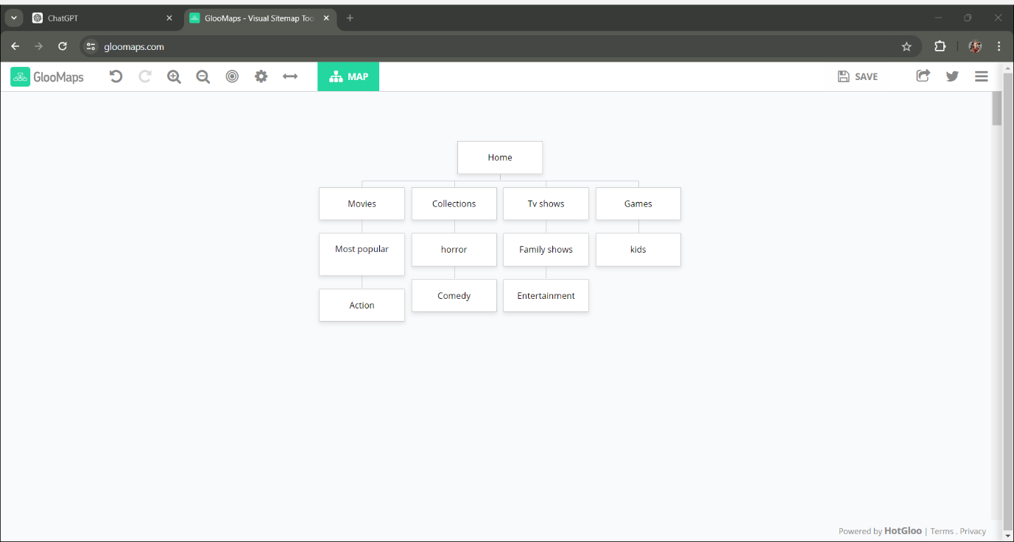

**PAGE TEMPLATE DESIGN**

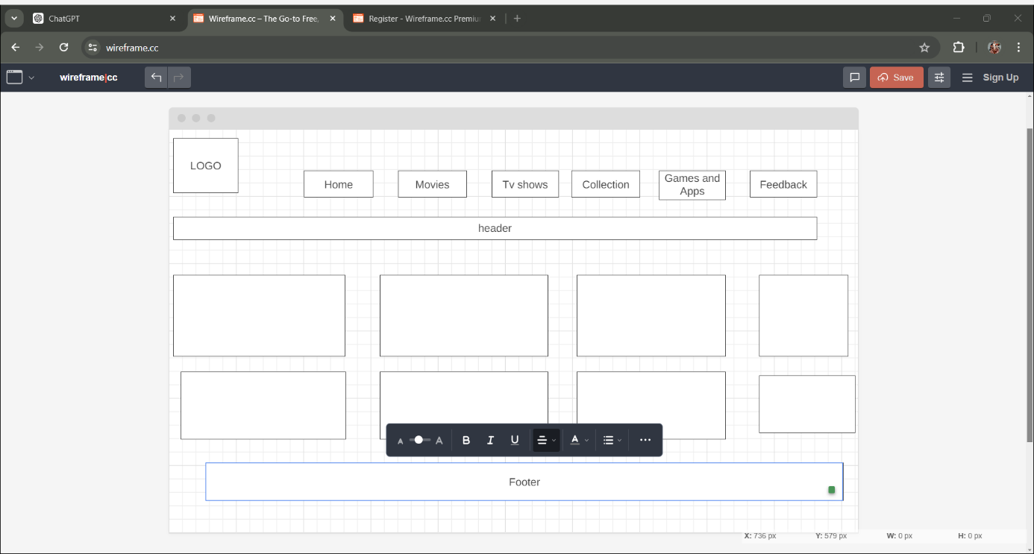

The wireframe above shows how my movie page will appear showing how i aligned my movies content.

My pages are differentiated by cascading style sheet

TECNICAL BRIEF

GRAPHIC TOOLS

Adobe illustrator

Box icon illustrator

QUALITY ASSURANCE

Quality assurance

Before going live, the website will be thoroughly tested to ensure that it works properly on a variety of devices and web browsers. Screenshots of the website will be taken across various platforms to ensure cross-platform compatibility.

First, I used Microsoft Edge as my default browser, and the results are shown below:

CHROME

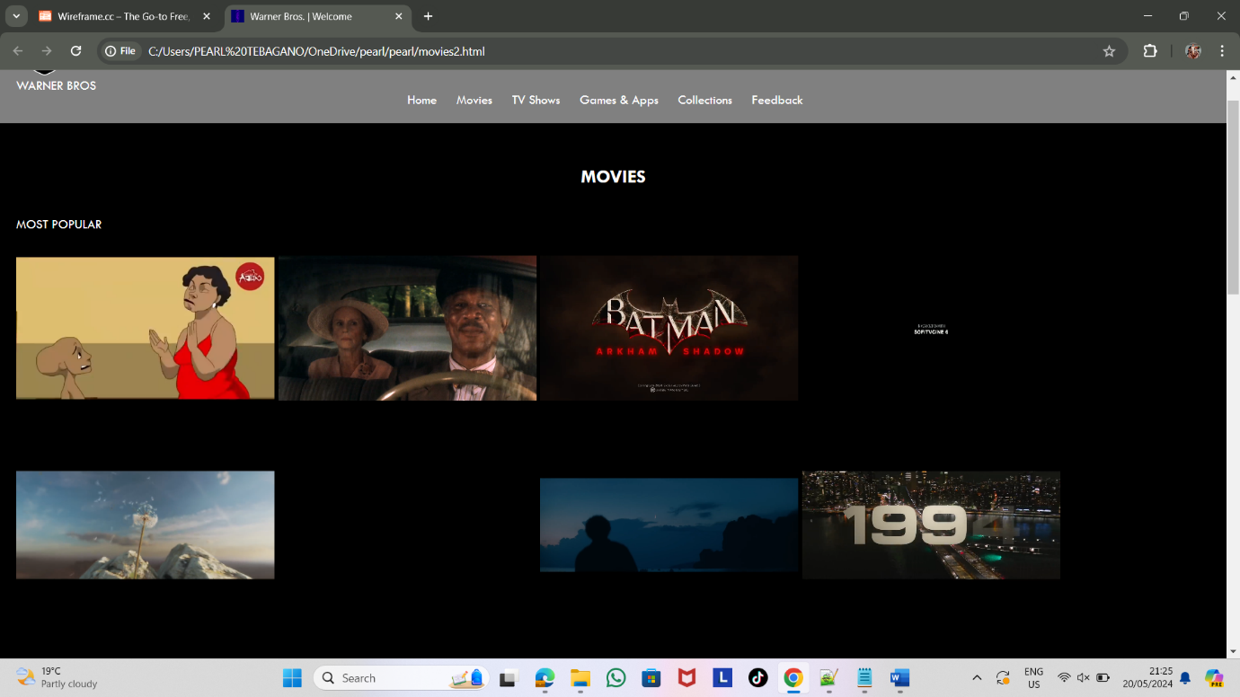

EDGE

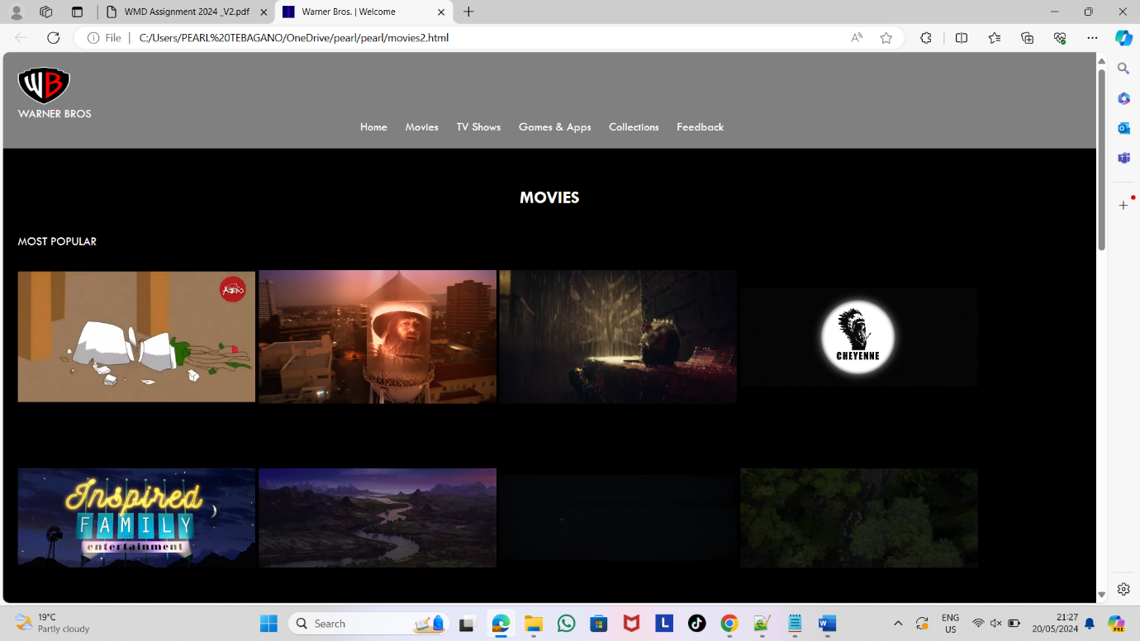

OPERA

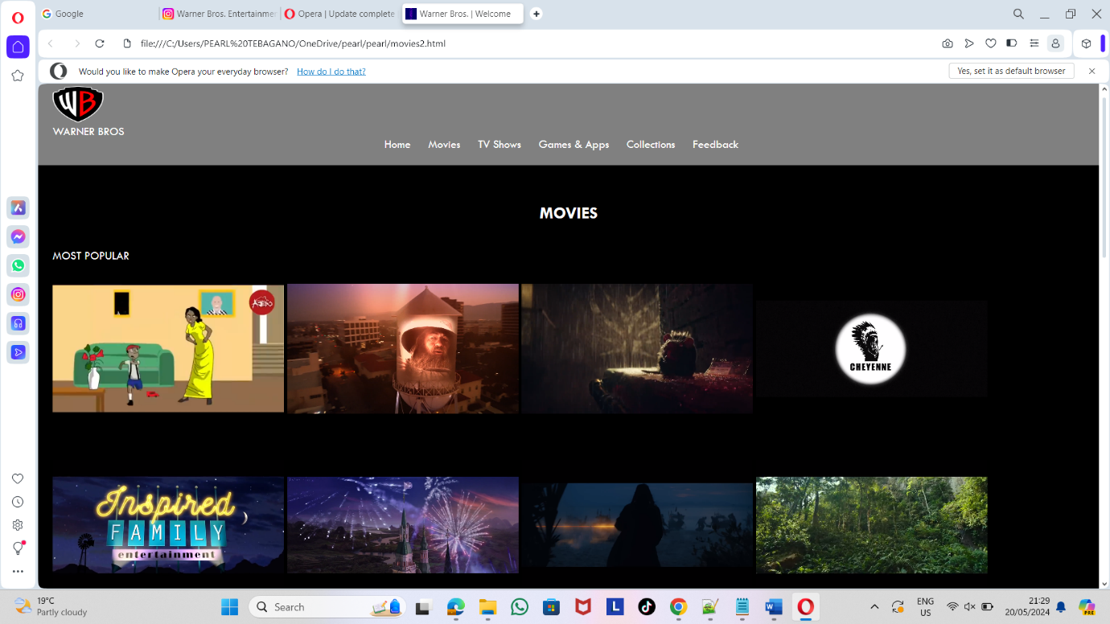

**PUBLISHING AND PROMOTION**

The next time, I'd include movies and GIFs to keep visitors on my site and engaged with my content.

I would add a marquee to allow viewers to see text over potentially fascinating photographs.

Integrate social media capabilities so that users can share their Favorite movies with their friends and followers, as well as rate and recommend them. Enabling social login options will make the user experience more seamless.

Creating a community around the website by including elements such as user comments, ratings, and reviews is critical for increasing user interaction. Encourage people to engage in conversations, express their ideas, and create a sense of community on the website.

Content Expansion: Keep the movie database updated.